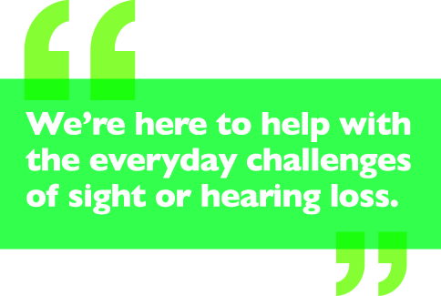
Need Help? Contact: Sensing Change
Stone Lodge Community Centre, Ipswich, Suffolk IP2 0QY Email: sensingchangeinfo@suffolk.gov.uk
Tel: 01473 260030 Fax: 01473 263029 Minicom: 01473 604345

Referral to Sensing Change Team
The information you provide us with will be treated as confidential although we may need to share what you have told us with other professionals. Are you happy for us to share this information? Is there anybody who you do not want us to share information with?
Please complete the following details about the person that needs to be referred to Sensing Change and return this form to the email or address above. Areas marked with a * are mandatory, any forms without this information will be returned.
REFERRAL MADE BY:
Name* | Address* | Tel No*
Profession/Relationship* | Agency/Team* | Date*
Have you discussed & obtained agreement for this referral? Yes/No

*REFERRAL AND BASIC INFORMATION
FULL NAME* | CF6 ID | DATE OF BIRTH* | GENDER*
PERMANENT ADDRESS* |  | CURRENT ADDRESS (IF DIFFERENT)*
POSTCODE* |  | POSTCODE*
PHONE NO’S* & EMAIL |  | MARITAL STATUS*
ETHNICITY* |  | LANGUAGE*
RELIGION* |  | OCCUPATION*
Nat Ins No* |  | NHS No:

Reason for referral
Please indicate

Hearing Loss Support Service Team
x
Sight Loss

Dual Sensory

Reason for referral – Please complete this section with as much information as possible e.g.
Diagnosed sensory condition - whether visual or hearing loss* Why is an assessment needed?* What difficulties is the person having?* How urgent is help needed?* Are there allegations of abuse or neglect?*
HAS THE PERSON BEEN REFERRED TO OTHER TEAMS OR AGENCIES?
CURRENT SUPPORT –
COMMUNICATION NEEDS – Large Print, British Sign Language, Audio, Braille*
GP DETAILS*
GP Name* |  | Name of Practice* |  | Tel No*
NEXT OF KIN/CONTACT IN AN EMERGENCY
Full Name* | Relationship* |  | Date of Birth (If appropriate)* |  | Gender*
Address*
Postcode*
Where did you hear about Sensing Change?
PLEASE SELECT ONE

THANK YOU
Where did you hear about Sensing Change – GP/Hospital/ACS/Self-Referral or Return/Other Agencies – Please select one.
Where did you hear about Sensing Change – GP/Hospital/ACS/Self-Referral or Return/Other Agencies – Please select one.
Please now return this form to sensingchangeinfo@suffolk.gov.uk

